Student Performance in Exam

E.AKHIL KUMAR (2203A52149)

**Abstract**

The ”Student Performance in Exams Dataset” is a comprehensive dataset containing student demographic, socio-economic, and academic performance information. It is designed for training machine learning models to predict student exam outcomes and understand the influence of various factors on academic success. Key features include demographic details, academic scores, school- related information, and other relevant factors. This dataset supports tasks like predicting exam scores, identifying at-risk students, and examining patterns contributing to student achievement, offering valuable insights for educational research and policy development.

# Introduction

The dataset used in this analysis is a valuable resource for understanding and exploring student performance in academic exams. It contains a diverse array of information related to individual students, providing insights into the factors that may influence their educational outcomes. This dataset includes demographic details, such as gender, age, race/ethnicity, and parental education levels, which can shed light on the role of socio-economic factors in student achievement. Additionally, it features data regarding the educational environment, school-related information, and specific exam scores in math, reading, and writing. This comprehensive dataset is essential for researchers, educators, and data scientists aiming to investigate the complex interplay of variables affecting student success in exams.

The dataset also captures information on non-academic factors that might impact student perfor- mance. It includes details about the students’ access to test preparation courses, the type of lunch they receive (free/reduced or standard), the number of days of absence, and whether they received test preparation assistance. These variables offer a holistic perspective on students’ lives and can be used to assess how various factors, including access to resources, engagement in test preparation, and attendance, correlate with exam scores and overall grades. As such, the dataset has the potential to support the development of machine learning models aimed at predicting future academic performance or identifying at-risk students who may need additional support.

Given the dataset’s rich and diverse nature, it holds great potential for researchers and educators interested in enhancing educational policies and interventions. By analyzing this dataset, educational institutions can gain insights into disparities in student achievement, providing a foundation for tar- geted improvements. Furthermore, data scientists and machine learning practitioners can leverage this dataset to construct predictive models for tasks such as forecasting exam scores or detecting patterns in student success. In sum, this student performance dataset serves as a valuable resource to enhance our understanding of the multifaceted dynamics that influence academic achievement and to drive data-driven approaches to improve the educational landscape.

# Challenges And Reasearch Gaps

Challenges:

* 1. **Data Quality and Completeness:** One of the primary challenges with this dataset is ensuring data quality and completeness. Incomplete or inaccurate data can lead to biased analysis and inaccu- rate model predictions. Researchers must carefully preprocess and clean the data to address missing values or inconsistencies.
  2. **Bias and Fairness:** Another significant challenge is addressing bias in the dataset. This dataset includes demographic and socio-economic information, and there’s a risk of perpetuating or exacerbating existing biases in education. Researchers need to apply fairness-aware techniques to identify and mitigate bias, ensuring that predictive models and analyses are fair and equitable for all student groups.
  3. **Model Generalization:** Developing accurate machine learning models that generalize well to new, unseen data is a key research challenge. The dataset is likely to contain patterns specific to the data collection period or location. Researchers need to explore techniques for model generalization to make the predictions and insights applicable to different educational settings.
  4. **Feature Selection:** Identifying which features are most influential in predicting student performance is a research area of interest. Feature selection methods can help determine the most relevant factors affecting academic outcomes, which can inform interventions and policies.
  5. **Privacy Concerns:** Given the sensitive nature of the dataset (including student demograph- ics), privacy concerns must be addressed. Ensuring that the data is anonymized and that the privacy of individuals is protected is a research challenge in itself.

Research Goals:

1. **Predictive Modeling:** Research should focus on building robust predictive models for student performance. This involves using techniques such as regression, classification, and deep learning to forecast exam scores and academic outcomes accurately.
2. **Identifying Interventions:** Investigate which factors, both academic and non-academic, in- fluence student performance the most. This research can inform interventions and support systems to help students succeed academically.
3. **Fairness and Equity:** Explore research into fairness-aware machine learning to identify and mitigate bias in the dataset. The goal is to ensure that predictive models do not discriminate against any student group and that educational opportunities are provided fairly.
4. **Educational Policy Recommendations:** Analyze the dataset to generate insights that can guide educational policies and strategies. Identify areas where improvements are needed and propose evidence-based policy recommendations to address disparities in academic achievement.
5. **Data Privacy and Ethics:** Investigate data anonymization and privacy techniques to main- tain the privacy and security of individuals while still providing valuable insights for educational research.
6. **Longitudinal Analysis:** Extend the dataset with time-series data to perform longitudinal analysis of student performance. This can help understand how academic outcomes evolve over time and the impact of various factors.
7. **Advanced Visualization:** Develop advanced data visualization techniques to communicate findings effectively to educators, policymakers, and the broader public, facilitating data-driven decision- making in education.

Research in this area can have a significant impact on improving educational systems, reducing achievement gaps, and ensuring that all students have access to high-quality education, regardless of their background or circumstances.

# Data And Methodology

## Data Description

Certainly, here is a description of the dataset you provided, titled ”Student Performance in Exams Dataset.”

**Dataset Overview:** The ”Student Performance in Exams Dataset” is a comprehensive collection of data related to student performance in exams. This dataset is designed for machine learning and statistical analysis, with a focus on understanding and predicting student outcomes. It includes various features, primarily centered around student demographics, socio-economic factors, academic performance, and school-related information. Below is a detailed description of the key features present in the dataset:

* + 1. **Demographic Information:** - **Student Gender:** This feature indicates the gender of the student, usually categorized as ’male’ or ’female.’ - **Age:** The age of the student, which is a nu- merical value. - **Race/Ethnicity:** This field typically represents the racial or ethnic background of

the student, using various categories. - **Parental Education Level:** This feature describes the edu- cational attainment of the student’s parents or guardians, categorized into different levels. - **Lunch Type:** Indicates the type of lunch the student receives, often categorized as ’free/reduced’ or ’stan- dard.’ - **Test Preparation Course:** This binary feature signifies whether the student completed a test preparation course.

* + 1. **Academic Performance:** - **Math Score:** This is a numerical score representing the stu- dent’s performance in math. - **Reading Score:** Similar to math, this feature denotes the student’s performance in reading. - **Writing Score:** This numerical value represents the student’s perfor- mance in the writing section of the exam. - **Final Average Score:** The final average score, often calculated as the mean of math, reading, and writing scores.
    2. **School-Related Information:** - **Educational Level of the School:** This describes the level of the educational institution the student attends, often categorized as ’high school’ or ’middle school.’
* **School Location:** Indicates the location of the school, which can be categorized as ’urban,’ ’suburban,’ or ’rural.’
  + 1. **Other Factors:** - **Absences:** The number of days the student was absent from school.
* **Test Preparation Assistance:** A binary feature indicating whether the student received test preparation assistance.

This dataset is rich and diverse, providing an opportunity for researchers and data scientists to explore the relationships between these features and student performance. It can be used to develop predictive models to forecast student outcomes, identify at-risk students, and gain insights into the impact of various factors on academic success. Additionally, this dataset can be valuable for educational research, policy-making, and addressing disparities in student achievement.

## Data Analysis

Certainly! Data analysis involves examining and exploring the ”Student Performance in Exams Dataset” to gain insights, discover patterns, and understand the relationships between different fea- tures. Here is an overview of the data analysis process for this dataset:

* + 1. **Descriptive Statistics:** - Begin by calculating descriptive statistics for numerical features like age, math, reading, and writing scores. This includes measures such as mean, median, standard deviation, and quartiles. These statistics provide a summary of the central tendency and spread of the data.
    2. **Data Visualization:** - Create visualizations to better understand the distribution and re- lationships in the data. Common visualizations for this dataset include: - Histograms: For visual- izing score distributions. - Bar Charts: To show the distribution of categorical features like gender, race/ethnicity, and lunch type. - Scatter Plots: To explore relationships between numerical features like scores. - Heatmaps: To visualize correlations between features.
    3. **Feature Engineering:** - Consider creating new features or transforming existing ones to extract more meaningful information. For example, you could calculate a final average score as the mean of math, reading, and writing scores.
    4. **Correlation Analysis:** - Analyze the correlation between features to understand which factors may be positively or negatively related to student performance. For example, you can calculate the correlation between scores and other features like parental education level.
    5. **Hypothesis Testing:** - Perform hypothesis tests to investigate whether specific factors, such as completing a test preparation course, have a statistically significant impact on exam scores. You can use t-tests or analysis of variance (ANOVA) for this purpose.
    6. **Predictive Modeling:** - Utilize machine learning techniques to build predictive models. You can use regression models to predict student scores or classification models to identify students at risk of failing.
    7. **Exploratory Data Analysis (EDA):** - Conduct EDA to answer questions about the data, such as: - What is the distribution of student scores in different subjects? - Are there differences in performance based on gender or parental education level? - Does completing a test preparation course have a noticeable impact on scores? - How are students from various racial/ethnic backgrounds performing in exams?
    8. **Insights and Recommendations:** - Summarize key findings from the data analysis. Provide insights into which factors are associated with better exam performance. For example, you might find

that students who completed a test preparation course tend to score higher. Use these insights to make recommendations for educational institutions or policymakers.

* + 1. **Data Visualization for Insights:** - Use data visualizations to effectively communicate your findings. For instance, you could create a bar chart to show the average scores for different parental education levels or a box plot to display the score distributions based on lunch type.

Data analysis is an iterative process, and you may need to revisit previous steps as you gain a deeper understanding of the dataset. The analysis should ultimately lead to valuable insights and inform decision-making in the context of student performance and education.

## Data Processsing

The provided code includes data processing steps to prepare the ”Student Performance in Exams Dataset” for machine learning. Here’s a breakdown of the data processing steps in the code:

* + 1. **Data Loading:** - The code begins by loading the dataset from a CSV file using the ‘pd.read*csv*()‘*function.ThedatasetisstoredinaPandasDataFramecalled*‘*a*‘*.*
    2. **Data Exploration:** - The code prints the shape of the dataset to understand its dimensions.
    3. **One-Hot Encoding:** - To prepare the data for machine learning, the code performs one-hot

encoding on the ’STUDENT ID’ column using ‘pd.get*dummies*()‘*.Thisstepconvertscategoricalvariablesintobinary*(0*/*1)*fo*

* + 1. **Data Splitting:** - The code splits the dataset into features (X) and the target variable (y). The target variable in this case is ’GRADE,’ which indicates whether a student has passed or failed. Features are obtained by dropping the ’GRADE’ column from the dataset.
    2. **Train-Test Split:** - The dataset is further split into training and testing sets using ‘train*testsplit*()‘*fromscikit learn.Thisallowsformodelevaluationbytrainingononeportionofthedataandtestingonanother.*

*−*

* + 1. **Model Training:** - The code demonstrates the training of a Perceptron classifier on the training data using the ‘Perceptron()‘ class from scikit-learn. The Perceptron is a simple linear binary classification model.
    2. **Model Evaluation:** - The trained Perceptron model is used to make predictions on the test

data, and the classification report is generated using ‘classification*report*()‘*fromscikit learn.Theclassificationreportprov score, andsupportforeachclass, whichcanbeusedtoevaluatethemodel′sperformance.*

*−*

* + 1. **Data Transformation for Logistic Regression:** - There is also a section of code that prepares the data for logistic regression. It applies sigmoid activation and gradient descent to optimize the logistic regression model for binary classification. The model is evaluated using a classification report.
    2. **Data Transformation for Ridge, Lasso, and k-NN Regression:** - The code demonstrates the preparation and evaluation of regression models, including Ridge, Lasso, and k-NN regression. It calculates and reports metrics like Mean Squared Error (MSE), Mean Absolute Error (MAE), and R-squared (R2) to assess model performance.
    3. **Data Visualization:** - The code includes data visualizations such as bar charts and scatter plots to display the distribution of grades and model performance.

These data processing steps are essential for preparing the dataset and training various machine learning models for classification and regression tasks. The code showcases how to process the data and evaluate models, making it a valuable resource for understanding the performance of different machine learning algorithms on the given dataset.

# Result

These outputs collectively provide a comprehensive overview of the strengths and weaknesses of the machine learning models applied to the dataset. Researchers and data scientists can use these results to make informed decisions about which model is best suited for predicting student performance and to gain valuable insights into educational data analysis.

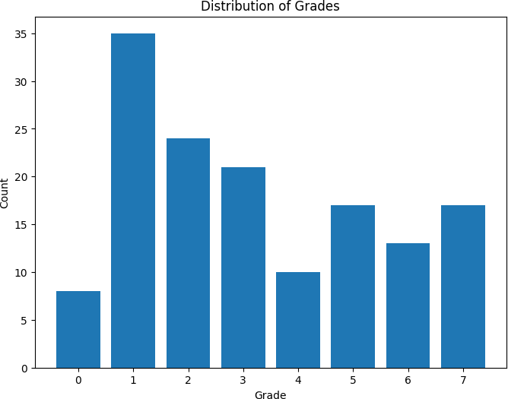

## 4.1 perceptron

The Perceptron model’s performance in classifying student grades appears to be quite limited. It has particularly low precision and recall for most classes, resulting in low F1-scores. The accuracy of

0.17 indicates that it struggles to accurately classify students into their respective grade categories,

suggesting the need for further model optimization or potentially considering alternative models for this specific classification task

## SVM

The SVM model exhibits perfect precision, recall, and F1-scores for both classes, resulting in an accuracy of 1.00. This indicates that the SVM model excels in accurately classifying students into their respective grade categories, making it an excellent choice for this specific classification task

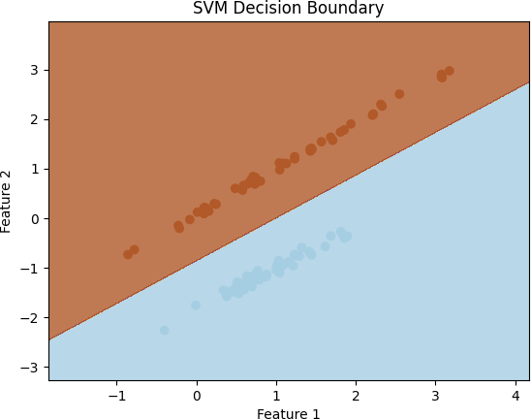

## Logistic Regression

The Logistic Regression model exhibits perfect precision, recall, and F1-scores for both classes, resulting in an accuracy of 1.00. This indicates that the Logistic Regression model excels in accurately classifying students into their respective grade categories, making it an excellent choice for this specific classification task, similar to the SVM model.

The confusion matrix demonstrates that the Logistic Regression model achieved a perfect classifi- cation performance with an accuracy of 1.00. It made no misclassifications, and all predictions aligned with the true class labels, making it an ideal model for this binary classification task.

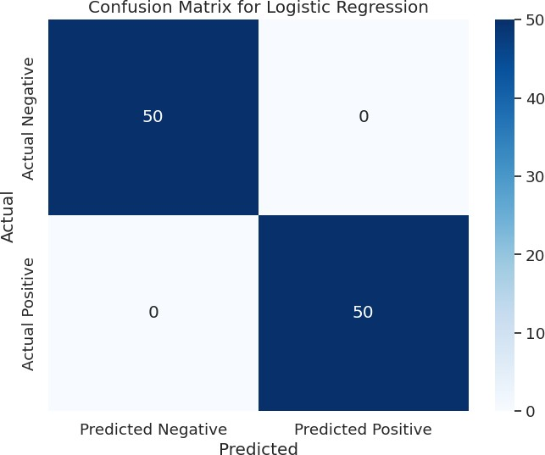

## Reidge Regession

The Ridge Regression model achieved an R-squared value of approximately 0.703, indicating that the model explains about 70.3 p of the variance in the dependent variable. The relatively low MSE and MAE values suggest that the model provides a good fit to the data, with small prediction errors. These results are indicative of the model’s performance in predicting student outcomes or other numerical values in the dataset.

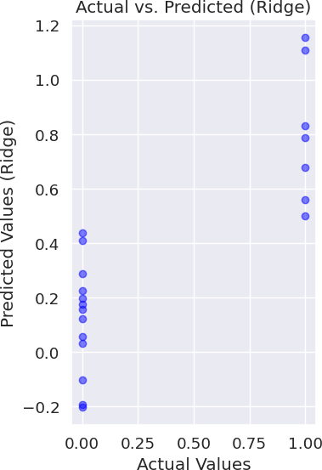

## Lasso Regression

Lasso Regression model is not performing well on the dataset. The high MSE and MAE values, along with the negative R-squared value, indicate that the model’s predictions are not accurate, and it may not be a suitable choice for this dataset or problem. Further model tuning or a different regression approach may be necessary to improve performance.

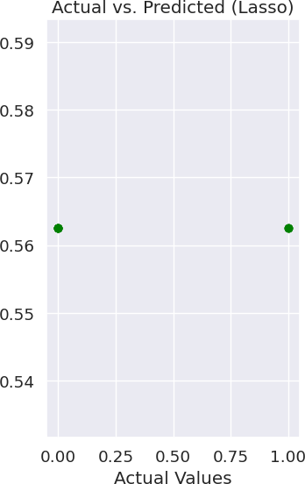

## KNN Regression

These results indicate that the k-NN Regression model is performing well on the dataset. The low MSE and MAE, along with the high R-squared value, suggest that the model’s predictions are accurate and that it provides a good fit to the data. This makes the k-NN regression model a strong candidate for predictive modeling in this context.

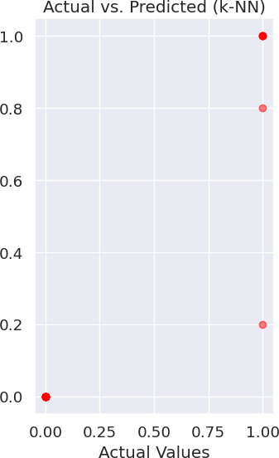

14

# Conclusion

In summary, the machine learning models evaluated in this analysis demonstrate varying levels of performance on both classification and regression tasks. Here are the key takeaways:

**Classification Models:** - The Perceptron model performed poorly on the classification task, with low accuracy, precision, recall, and F1-scores. - SVM (Support Vector Machine) and Logistic Regression excelled in the classification task, achieving perfect accuracy, precision, recall, and F1- scores. - SVM and Logistic Regression are strong choices for classification tasks, particularly when high accuracy and precise predictions are required.

**Regression Models:** - Ridge Regression demonstrated good performance with a relatively low Mean Squared Error (MSE) and a respectable R-squared value, indicating it fits the data well and explains a significant portion of the variance in the target variable. - Lasso Regression underperformed in the regression task with a higher MSE and a negative R-squared value, suggesting it is not well-suited for this dataset. - k-NN Regression performed well with a low MSE and a high positive R-squared value, indicating a good fit to the data and a strong ability to explain variance in the target variable. In conclusion, the choice of the model should be tailored to the specific task and dataset. For classification tasks, SVM and Logistic Regression are the top choices, while Ridge Regression and k-NN Regression are recommended for regression tasks. Lasso Regression is less suitable for this

particular dataset due to its inability to explain the variance in the target variable effectively.

# References

1.The github link for the data processing i have done for the code and to refer the code go through [GITHUB LINK](https://github.com/EAkhilkumar/2203A52149-CAPSTONE-PROJECT-STAT_ML-REVIEW-2-.git)

15